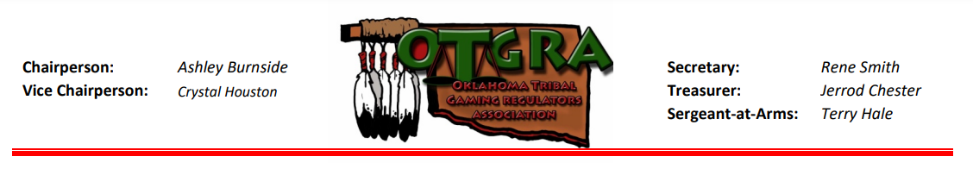
OTGRA SPONSORSHIP OPPORTUNITIES
FALL CONFERENCE – CHOCTAW RESORT CASINO - NOVEMBER 15-17, 2022

Platinum Level Sponsor - $5,000
- Pick EITHER Welcome Reception OR Awards Banquet as Exclusive Sponsor of chosen event
- Premier recognition at selected event (Welcome Reception or Awards Banquet)
- Prominent name and logo recognition at event not selected (Welcome Reception or Awards Banquet)
- Premier name and logo recognition throughout the conference and in conference materials
- Premier name and logo recognition at Jess Green Memorial Scholarship Tournament (if applicable)
- Co-sponsor Logo recognition on photo booth sponsor (with photo booth sponsor)
- Thank you for providing Giveaways promoting your brand for “swag bags” (250 +/- items needed)

Gold Level Sponsor - $3,000
- Recognition throughout the conference and in conference materials
- Prominent name and logo recognition at the Welcome Reception
- Prominent name and logo recognition at the Awards Banquet
- Thank you for providing Giveaways promoting your brand for “swag bags” (250 +/- items needed)

Silver Level Sponsor - $1,500
- Recognition throughout the conference and in conference materials
- Prominent name and logo recognition at Welcome Reception
- Thank you for providing Giveaways promoting your brand for “swag bags” (250 +/- items needed)

Bronze Level Sponsor - $1,000
- Recognition throughout the conference and in conference materials
- Thank you for providing Giveaways promoting your brand for “swag bags” (250 +/- items needed)

Professional Head Shot Sponsor - $1,000
- Recognition throughout the conference and in conference materials
- Option to provide a customized photo sleeve for Head Shots
- Thank you for providing Giveaways promoting your brand for “swag bags” (250 +/- items needed)

Photo Booth Sponsor - $1,000
- Recognition throughout the conference and in conference materials
- Thank you for providing Giveaways promoting your brand for “swag bags” (250 +/- items needed)

Breakfast and/or Break Sponsor - $800
- Recognition throughout the conference and in conference materials
- Prominent name and logo recognition at the Breakfast(s) or Break(s)
- Thank you for providing Giveaways promoting your brand for “swag bags” (250 +/- items needed)

Friends of OTGRA - $250
- Thank you for providing Giveaways promoting your brand for “swag bags” (250 +/- items needed)

JESS GREEN MEMORIAL SCHOLARSHIP TOURNAMENT
Gold Level Event Sponsor - $500
- One (1) complimentary team - a $200 Value!
- Prominent name and logo recognition at tournament and in conference materials

Silver Level Event Sponsor - $250
- Prominent name and logo recognition at tournament and in conference materials
~ Thank you for participating in the OTGRA Fall Conference ~

