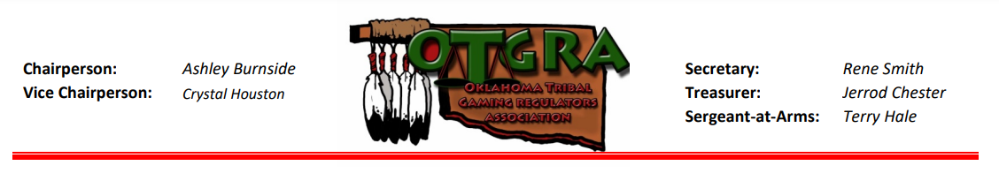
2022 OTGRA Fall Conference
November 15-17 ● Choctaw Casino Resort ● Durant, OK
Registration Form

Register by Monday, October 31st to Save $25 for early registration

NAME (as it should appear on badge): Click or tap here to enter text.
TRIBE/COMPANY: Click or tap here to enter text.
ADDRESS: Click or tap here to enter text.
CITY, STATE, ZIP: Click or tap here to enter text.
EMAIL:Click or tap here to enter text. PHONE:Click or tap here to enter text.

Please mark the box(es) indicating your registration choice:
☐ OTGRA Member Conference & Banquet $300
☐ OTGRA Member Conference ONLY $275
☐ Non-Member Conference & Banquet $350
☐ Non-Member Conference ONLY $325
☐ 1 Extra Banquet Ticket for:Click or tap here to enter text. $ 30
☐ Add $25 Late Registration Fee after October 31st $ 25

TOTAL $Click or tap here to enter text.
Cancellation Policy: Prior to October 17th, OTGRA will issue a refund less a $100 processing fee.

Method of Payment

CHECK – Please make payable to OTGRA. Mail with registration form to address below.

CREDIT CARD – Please charge my credit card $Click or tap here to enter text. + *4% processing fee
☐Visa ☐MC ☐ AE Card #:Click or tap here to enter text. Exp. Date:Click or tap here to enter text.
Security Code:Click or tap here to enter text. Billing Zip Code:Click or tap here to enter text.
Print Name (as it appears on the card):Click or tap here to enter text.

Signature: __________________________________________________________________

*A 4% Processing Fee will be added to all credit card transactions

Mail Check and Registration to:
Jerrod Chester/OTGRA
c/o Miami Tribe Gaming Commission
P.O. Box 1326
Miami, OK 74355

