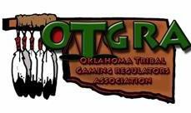

OTGRA Meeting @ OIGA
Business Meeting @ 1pm (Bring a Box Lunch from Tradeshow Floor)
Room 201

BUSINESS MEETING AGENDA

I. Call to Order
II. Roll Call – Establish Quorum
III. New Business
1. Approval of Minutes – June 30th, 2021
2. Treasurer’s Report
3. Association Updates
• OIGA
• NTGCR
. NIGA
IV Old Business
V. Announcements & Open Forum
VI. Adjourn

2021 -2022 Meeting Dates
• August 18th, 2021 OIGA Tradeshow & Conference (Bi-Monthly Meeting)
• October 13th, 2021 Bi-Monthly Meeting Via Zoom
• December 7th, 2021 – “In Person” Bi-Monthly Meeting @ VGT-Tulsa, OK
• February 2022-Bi-Monthly Meeting-TBA
. April 25-27, 2021-Spring Conference-Choctaw Casino, Durant, OK

www.OTGRA.org www.facebook.com/OTGRA

