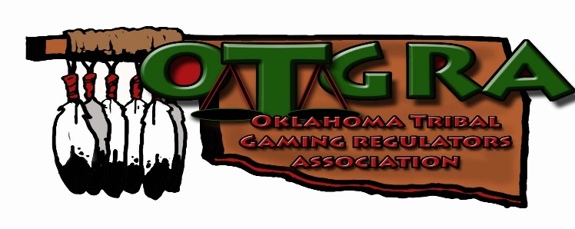

OTGRA SPRING CONFERENCE 2020
Choctaw Casino Durant
April 7th & April 8th 2020

OTGRA requests nominations to recognize an outstanding regulator for demonstrating exemplary service at the OTGRA Awards Banquet for the Jon Arrasmith Regulator of the Year.

Jon Arrasmith was a member of Citizen Potawatomi Nation and served as OTGRA Treasurer from 2012 until his untimely passing in 2014. Jon was extremely dedicated and passionate about tribal regulation and was a role model to many within his tribe and community.

This award is to celebrate the life of Jon Arrasmith and honor an individual who upholds his legacy by awarding him/her the “2020 Jon Arrasmith Regulator of the Year” Award.
The nominee meets the following criteria:
- Substantial dedication to OTGRA’s Mission and Goals.
- Active representative of a member tribe within the OTGRA in a regulator role.
- Commitment to Indian Gaming Regulation.
The recipient will be honored at OTGRA’s 2020 Spring Conference at the Choctaw Durant Casino in Durant, OK on the evening of Tuesday, April 7th, 2020.

Please complete this form and email it to Kristi Cole at kristi-cole@cherokee.org . Submit nomination by 4:00 p.m. February 7th, 2020.

I, (Your name) _________________________________, on behalf of the (your tribe)______________________________________
nominate _____________________ of the (Nation) ___________________________ for the Jon Arrasmith Regulator of the Year.
In the space below, please provide a brief description of why you feel the above named nominee should be considered for the
“2020 Jon Arrasmith Regulator of the Year Award”
____________________________________________________________________________________________________________________________________________________________________________________________________________________________________________________________________________________________________________________________________________________________________________________________________________________________________________________________________________________________________________________________________________________________________________________________________________________________________________________________________________________________________________________________________________________________________________________
Signature: __________________________________________ Date: ____________________________________________________

