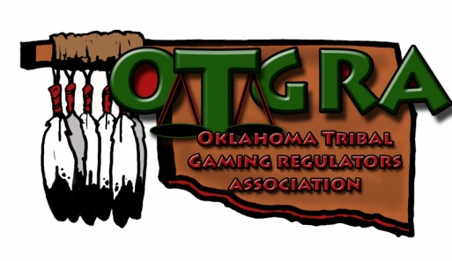
OKLAHOMA TRIBAL GAMING REGULATORS ASSOCIATION

MEMBERSHIP FEES

Pursuant to the Association By-Laws Membership fees shall be paid in January for all Tribes, entities, or individuals wishing to become a member of the Oklahoma Tribal Gaming Regulators Association.

There are two (2) forms of OTGRA Membership as follows:

Voting Members shall include Tribal Gaming Commissions, Gaming Commission Staff, and individuals involved in regulation for that Tribe. Each Tribe shall submit a membership fee of $200.00 and shall list on the application all individuals under that Tribe’s Commission, etc., who shall be considered an OTGRA voting member for that Tribe.

Associate Members may join the OTGRA as well. An Associate member is an entity, or individual not with a Tribe but who has an interest in regulatory issues (i.e., private attorneys, vendors, testing labs, individuals). The Associate Members shall not be eligible to vote but are invited to attend all meetings and conferences. The fee for Associate Members is as follows:

Associate Member Entity (Company): $100.00
All Employees listed on the application shall be considered Assoc. Members.
Associate Member Individual: $50.00

Please complete the attached Membership Application Form and submit it with your check payable to the OTGRA at the following address:

Traci L. Atkinson
OTGRA Secretary
P.O. BOX 1160
Perkins, OK 74059

QUESTIONS: Please call…
Traci Atkinson, Secretary, at 405-547-1097 x 21

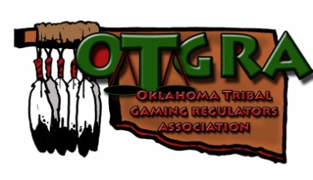

2019 MEMBERSHIP APPLICATION
OKLAHOMA TRIBAL GAMING REGULATORS ASSOCIATION

Type of Member:
□ Voting Member (Tribes $200.00 fee)
□ Associate Member (Non-tribal Entity $100.00 fee)
□ Individual ($50.00 fee)

Name of Tribe/Entity/Individual:
Address:
 | Address |  |  |  | City |  | State | Zip
Phone Number:
Contact Name:
Contact Email address:

List Name and Title of each person with your Tribe/Entity to be considered an OTGRA Member under your Tribe/Entity. (Each Tribe/Entity shall be responsible for
keeping the OTGRA informed of any additions or deletions of names listed below). Please attach a separate sheet and list each members email address if they wish to get email notifications about OTGRA meetings, conferences and info.
NAME |  | TITLE
1.
2.
3.
4.
5.
6.
7.
8.
9.
10.

Mail Check & Application to:
Traci Atkinson/OTGRA
c/o Iowa Tribe Gaming Commission
P.O. Box 1160
Perkins, OK 74059
Date Received: Ch#

Amount:

Method of Payment
CREDIT CARD – Please charge my credit card $__________ + 4% processing fee VISA MC AE
Card # _________________________________ Exp. Date _______________ Security Code _______________
Billing Zip Code ____________ Print Name (as it appears on the card) ___________________________

Authorized Signature:
__________________________________

